DAY-6 AEM TASK

1.AUTHOR COMPONENT AND ITS HTML FILE

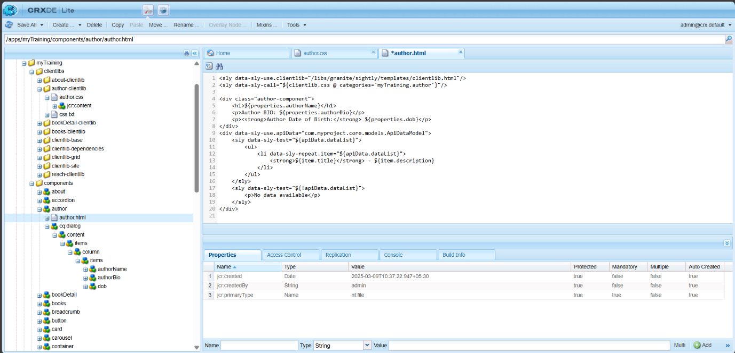

2. JAVA SCRIPT FILE FOR AUTHOR COMPONENT

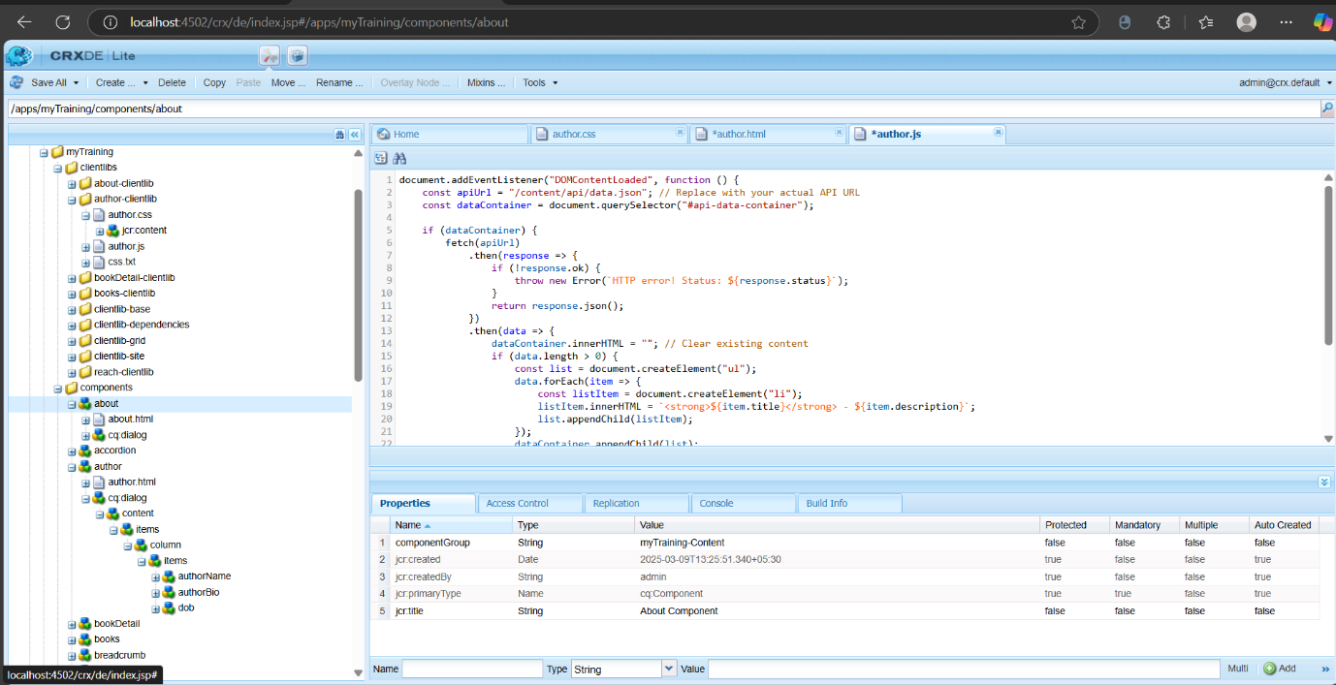

3.AUTHOR COMPONENT IN TEMPLATE

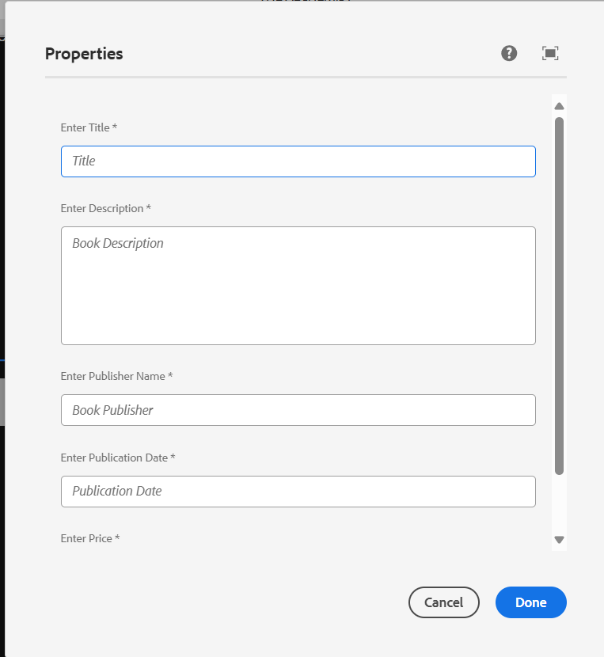

4.AUTHOR MODEL FILE FOR IMPLEMENTATION

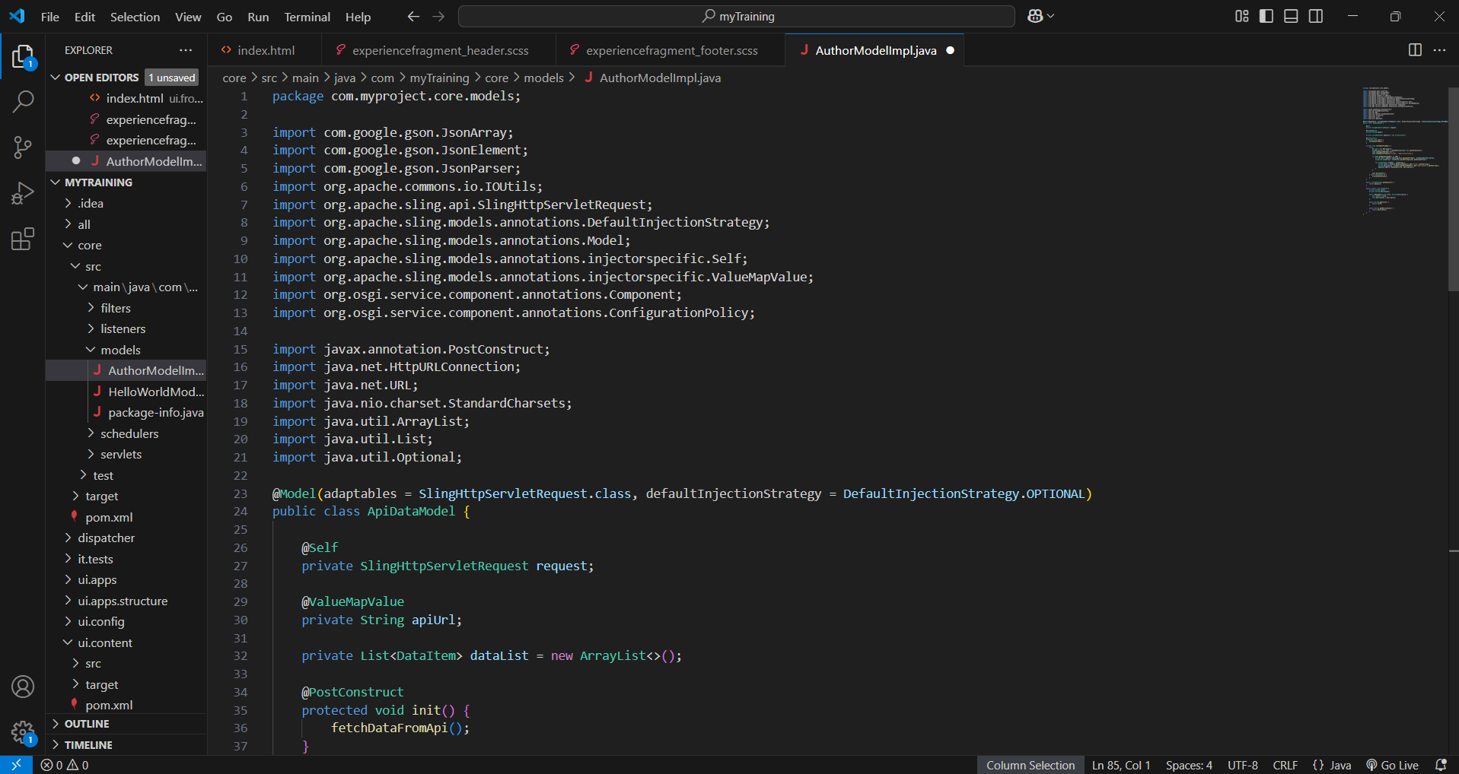

5. BOOK PAGE COMPONENT IN THE CARD VIEW

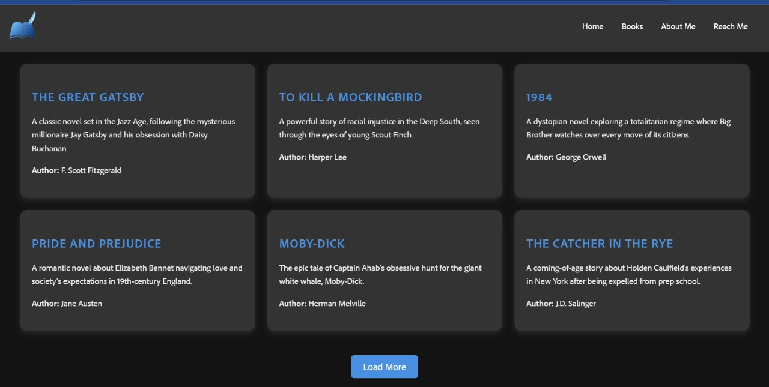

6.CUSTOM CONFIGURATION FILE

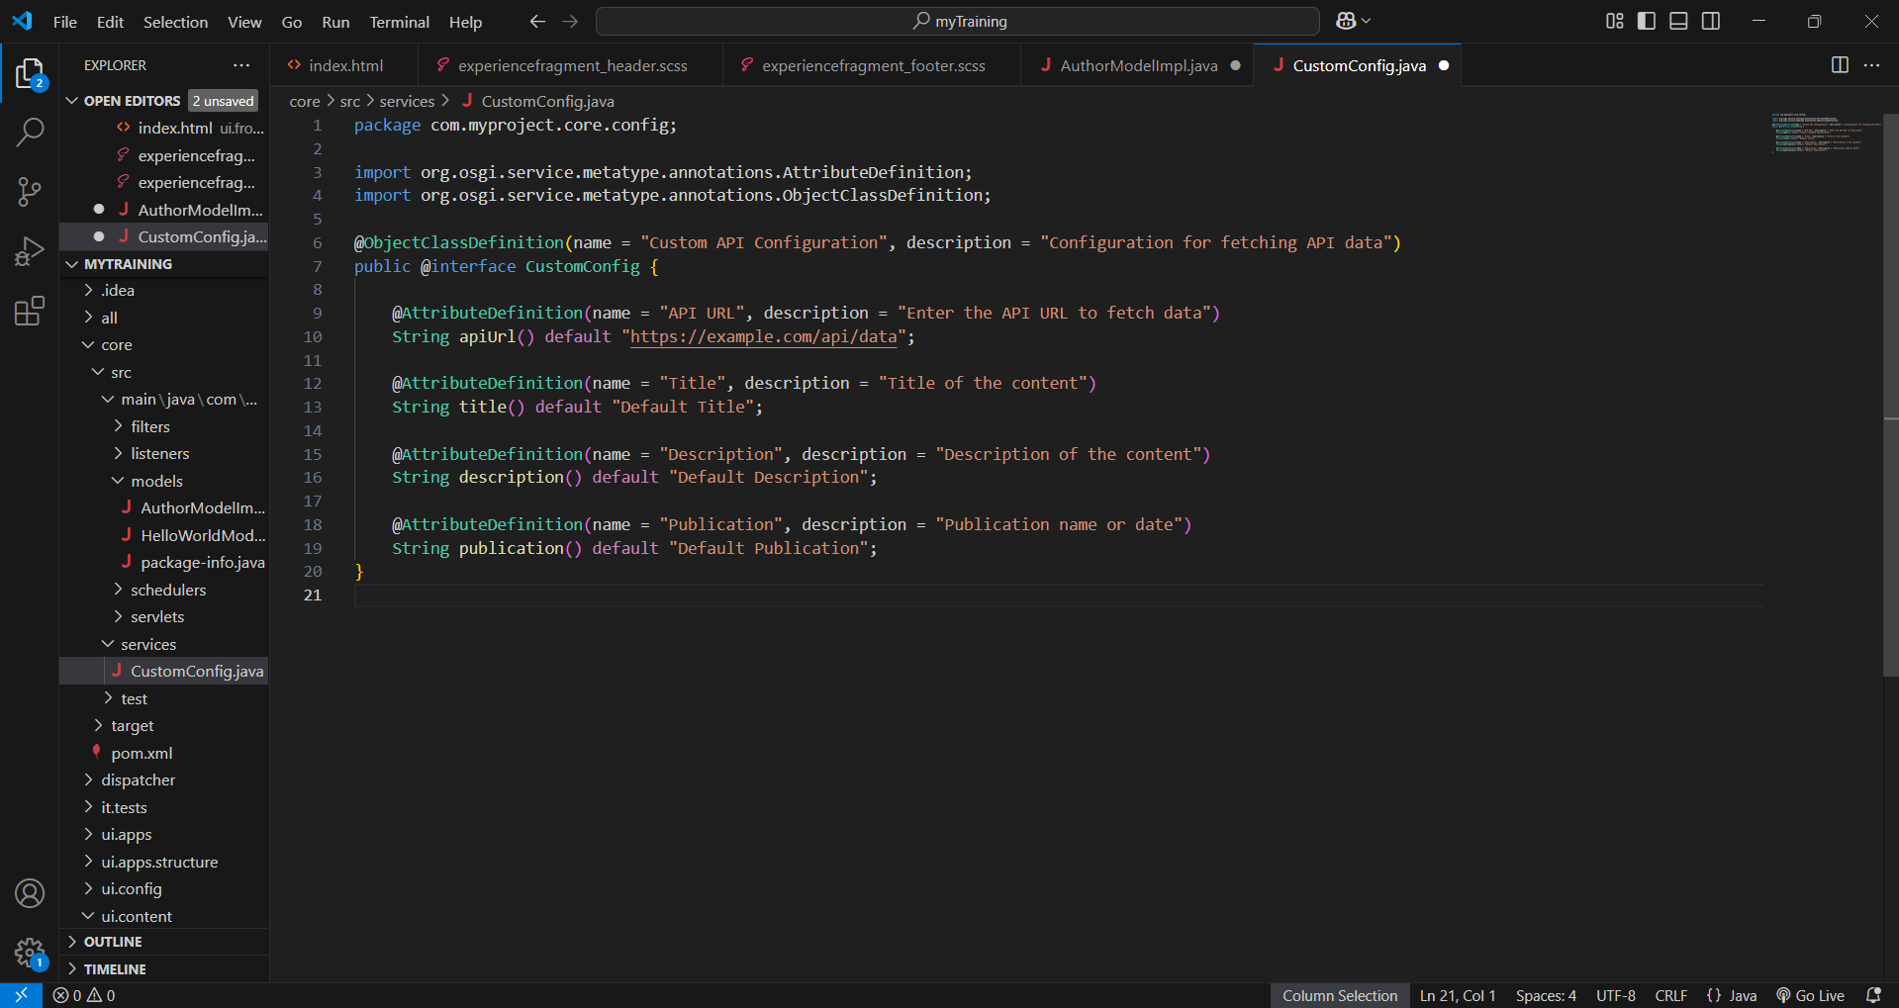

7. SERVICES AND ITS IMPLEMENTATION FILES

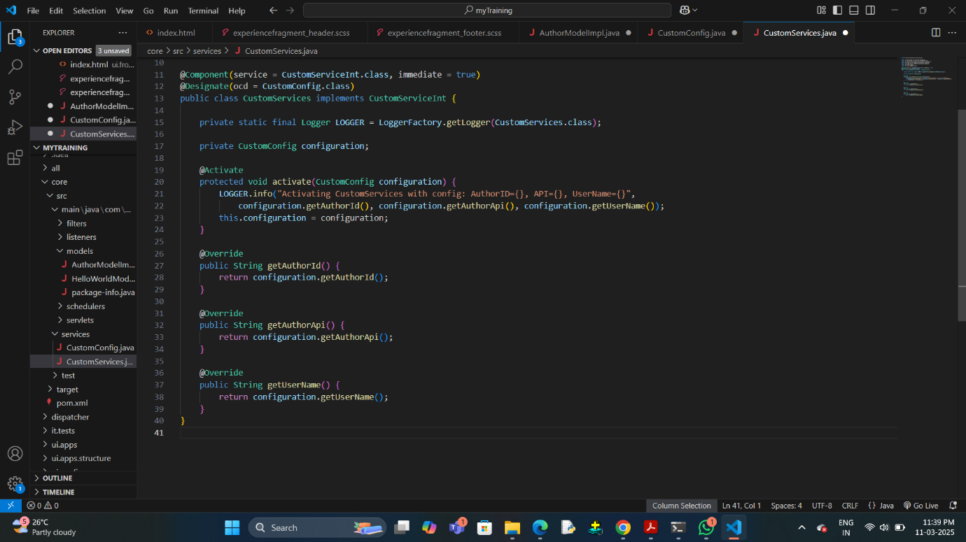

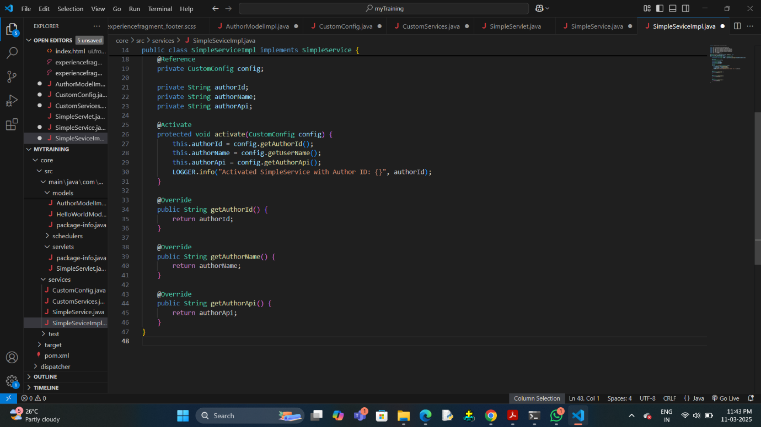

8. SERVLET FILES

